**Assignment 1**

Q 1• Install Power BI Desktop and share the final screenshot of the report view page which appears when power desktop starts.

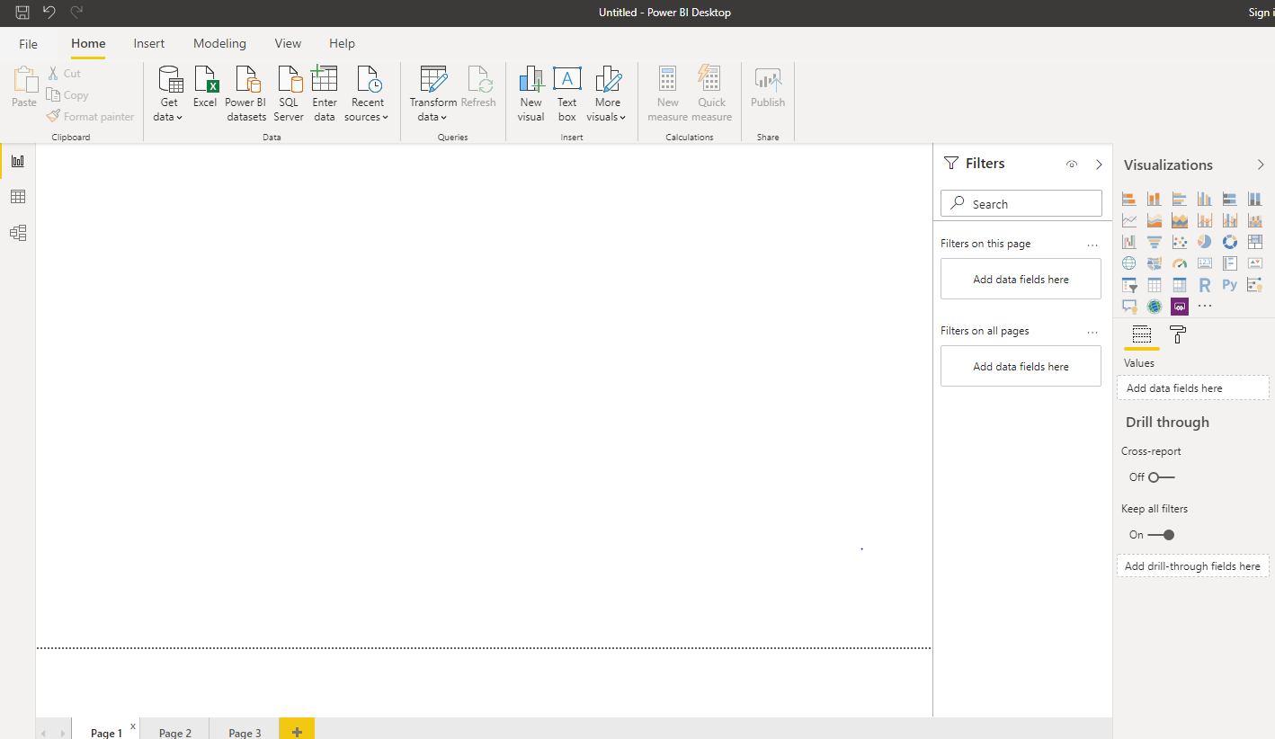

Q 2 • Prepare a document and with the following screenshot

− Report View 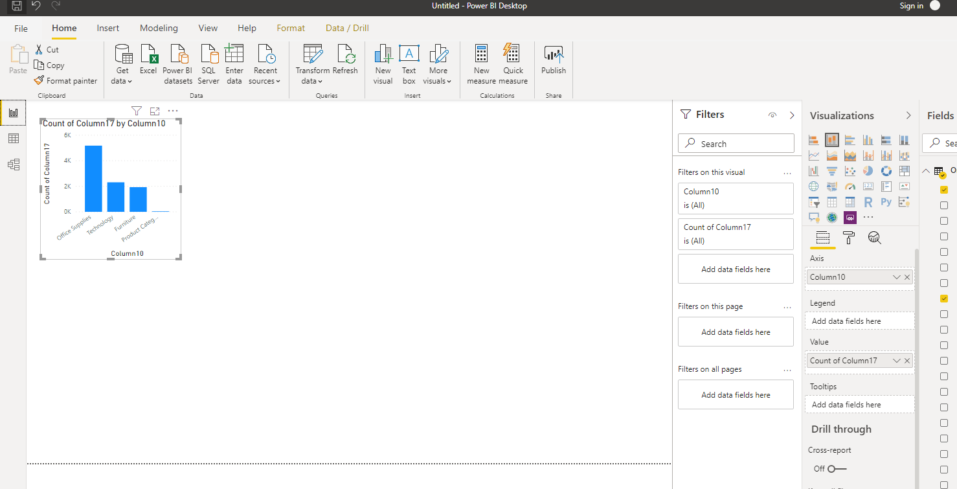

− Data View

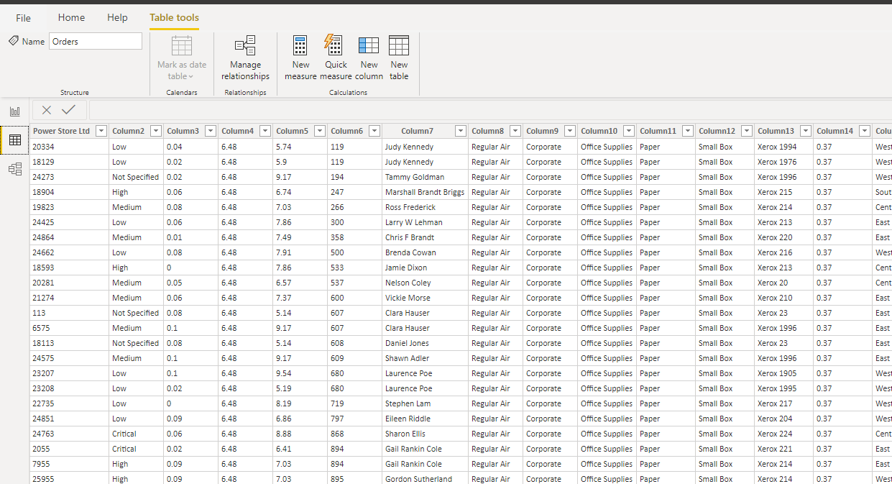

− Model View

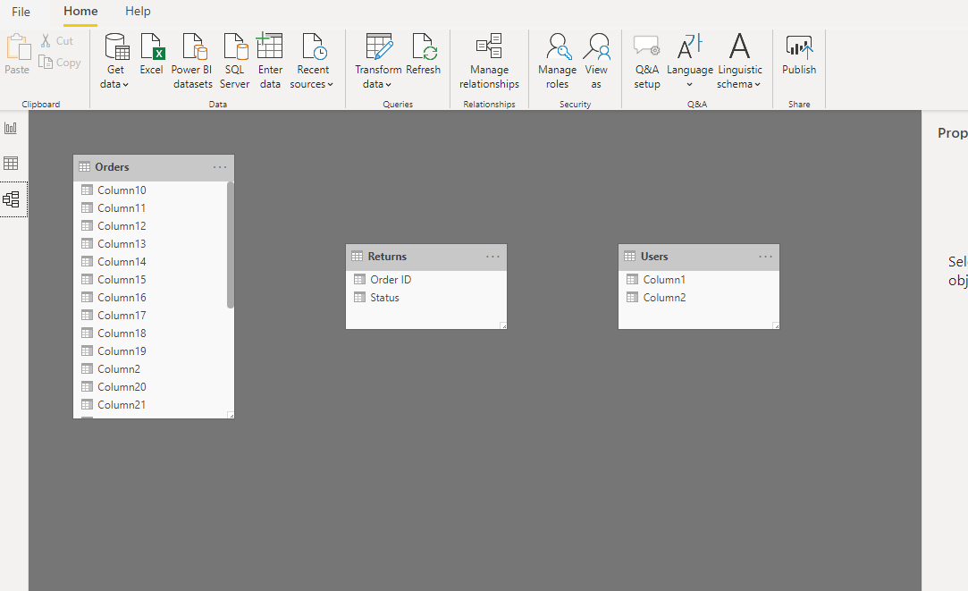

− Power Query Editor

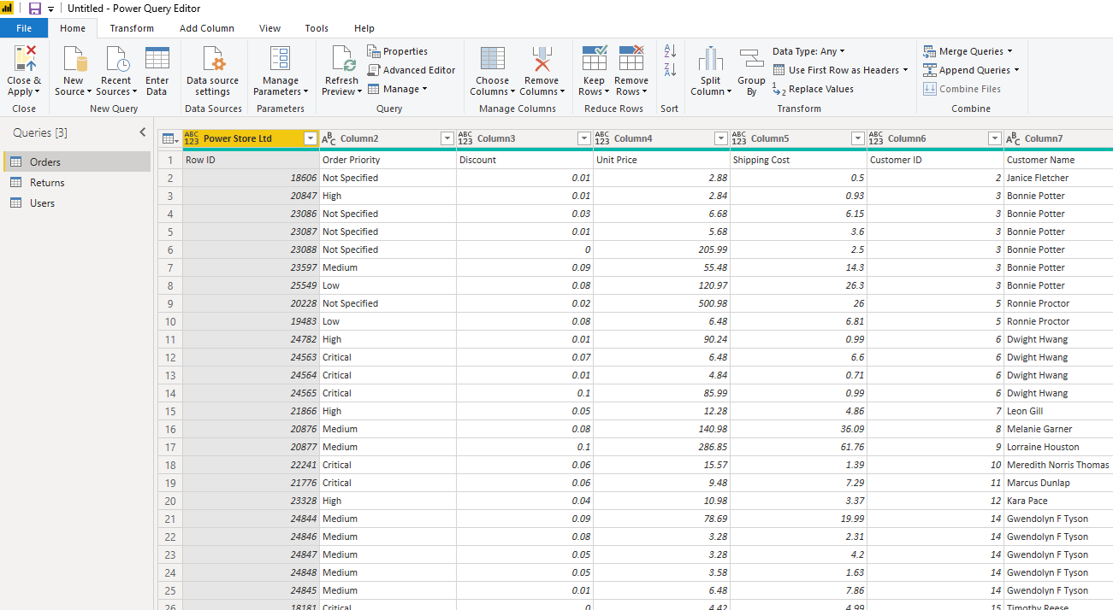

− Advance Editor

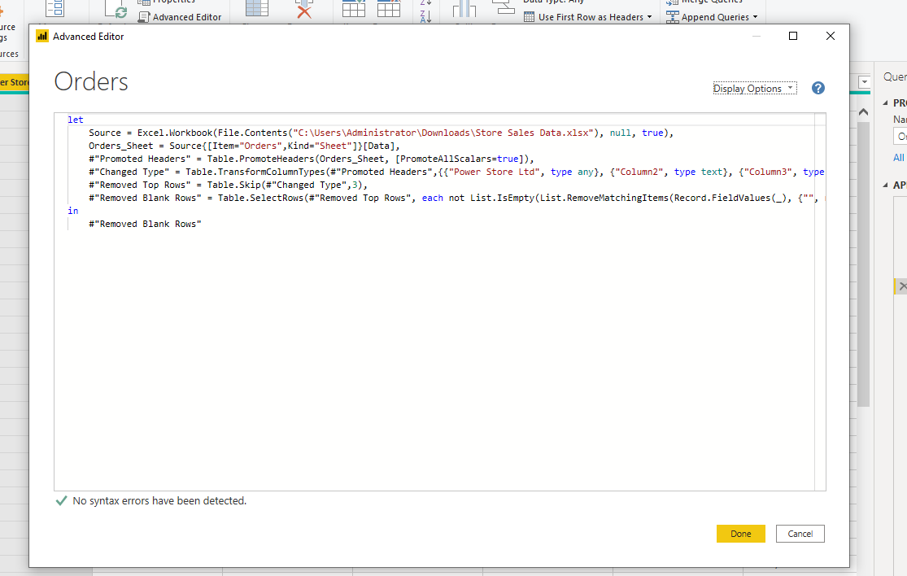

**Q 3 • Prepare a document with details of the following along with their price**

**− Power BI Desktop**

Power BI desktop is the primary authoring and publishing tool for Power BI. Developers and power users use it to create brand new models and reports from scratch.

**Cost**- **Free**

**− Power BI Pro**

* Self-service and modern BI in the cloud
* Collaboration, publishing, sharing, and ad-hoc analysis
* Fully managed by Microsoft

**Cost**- **$9.99**

**− Power BI Premium**

* Enterprise BI, big data analytics, cloud and on-premises reporting
* Advanced administration and deployment controls
* Dedicated cloud compute and storage resources
* Allows any user to consume Power BI content

**Cost**- **$4,995**